Client Name:
Sheronda Baisy
Client Address:
441 Silkwood Drive, Bryan, 77803
Phone Number:
979-213-8125

Distance from the Church:
2.7 miles - 8 minutes

Description of the work:
Demo existing broken deck
Replace with larger 8x16 deck

Other Notes:
There is a set of concrete stairs that we will reuse
Look into patching small hole in wall from tree falling
Potential shade under car canopy
Very talkative child

Site Pictures
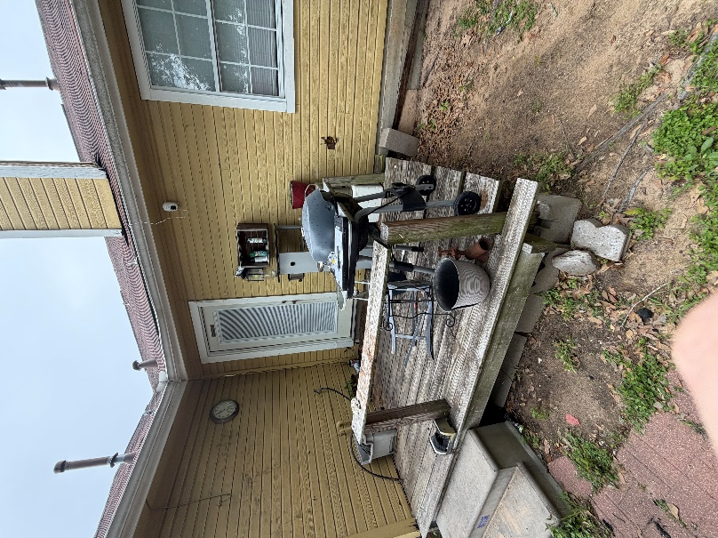
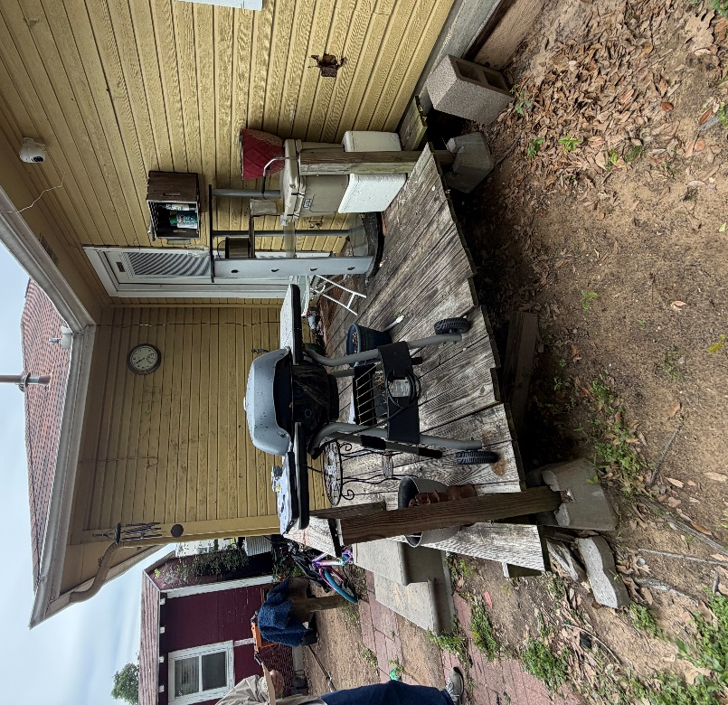
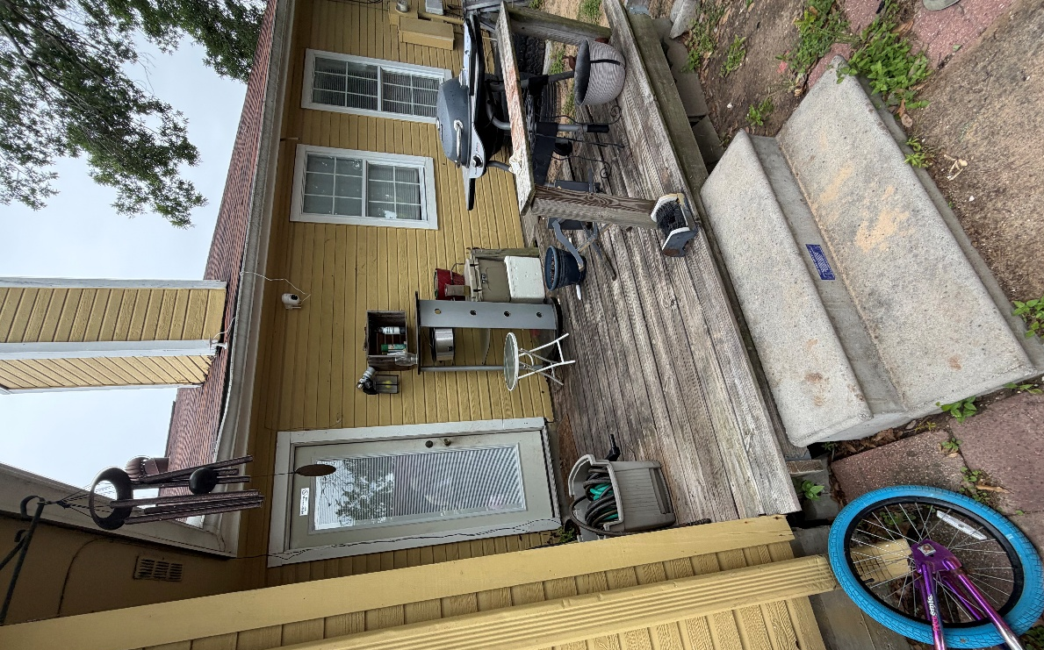

Rendered Project
“Build to site not to plan”
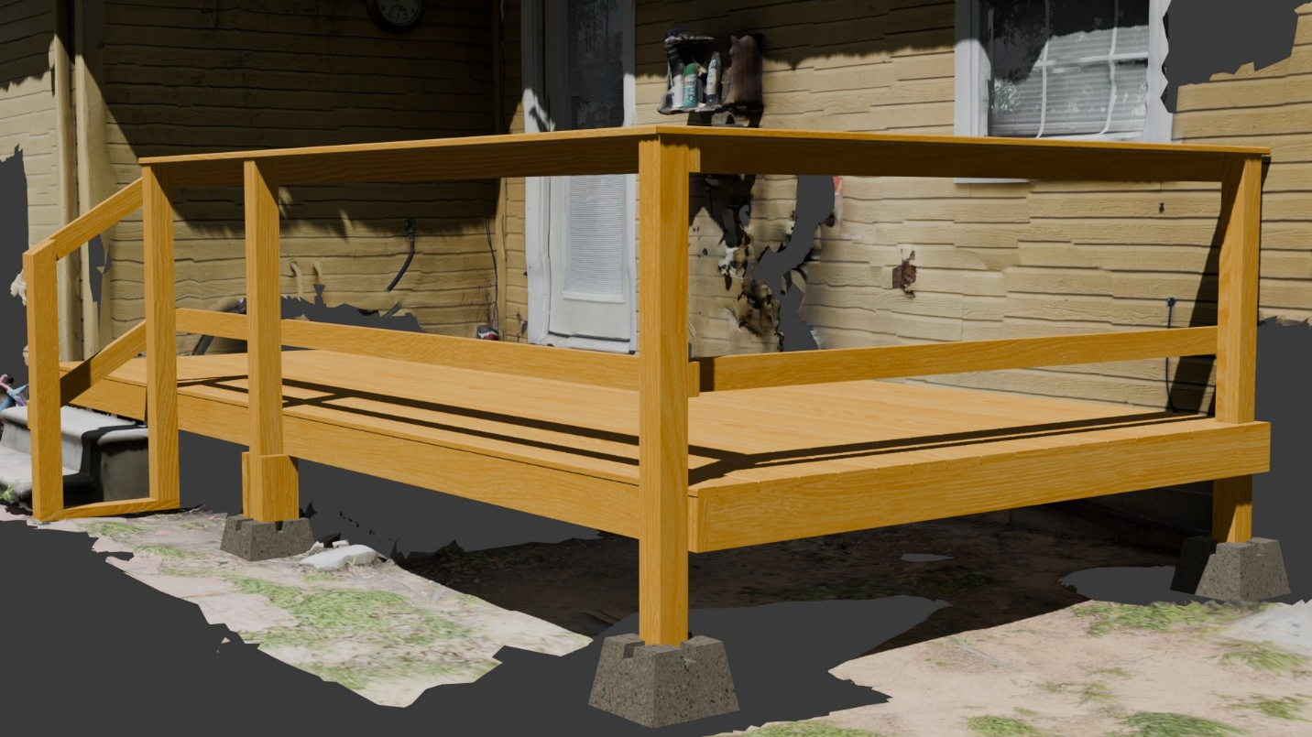
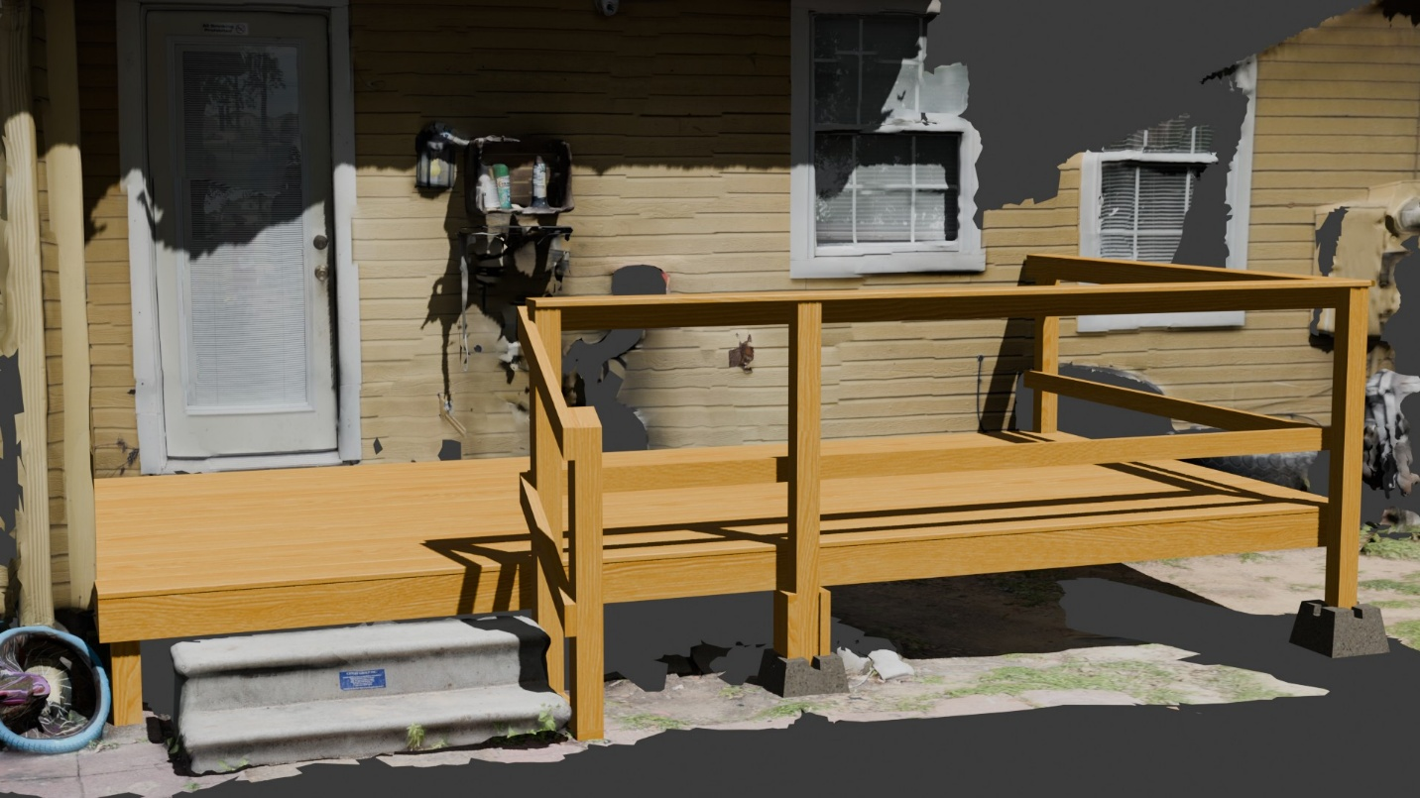
Building Notes
- Frame
  - Focus on the “Top-left” closest corner to the house
  - See if paver or deck block will be used
  - Check with the client if they want a full 8ft or to the end of the house
- Joists
  - Middle posts interfere with perfect joist spacing
  - Move either the back post or joist
- Posts/cleats
  - Use 2x6 cleats on the middle posts
  - Don’t forget to cleat the back
- Handrails
  - Watch lumber used
- Decking
  - You will have to cut out a post and rip one board
- Special Handrail
  - Attach a 2x4 to the bottom of the 4x4 before mounting to frame
  - Use the pavers to create a level surface for the stairs and handrail
  - Add extra support as needed

